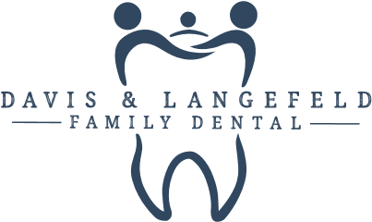

Request To Release Dental Records/Radiographic Information

I have requested that Dr. ________________ make available to me, or forward on my behalf to Davis & Langefeld Family Dental, my dental records and radiographs. If the radiographs are digital, please send them by email.

Thank you,

______________________________
Patient’s Name

______________________________ ___________________
Patient’s Signature Date

Dr. Jeff Langefeld, Dr. Melissa Davis
3448 N Old Arlington Heights Rd, Arlington Heights, IL 60004 (847)255-2968
Fax (847)255-7472 | info@dlfamilydental.com

